Investigating Circles
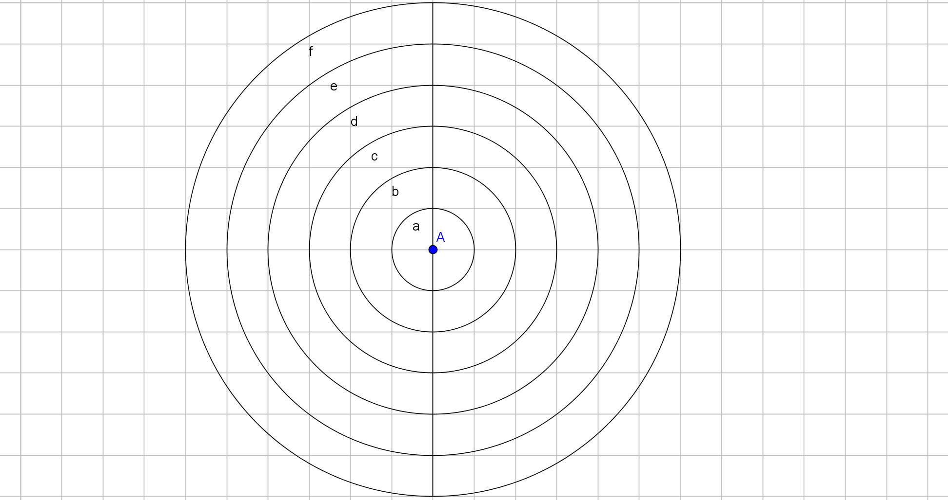

Circle | Radius (r) | Diameter (d) | Circumference (C) | C$÷$d
a
b
c
d
e
f

What do you notice?

